CELLULAR MEMBRANES: Effects of Physical and Chemical Stress

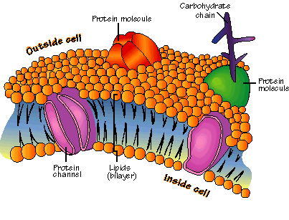Part 2: Independent Study

In this part of the experiment you will test other treatments which you may believe will or will not disrupt the cell membrane. It is obvious that cutting or mashing a beet will disrupt the membrane. However, now consider other physical or chemical treatments which may stress the cell membrane. Consider what you learned from the pilot study and based on your knowledge of the cell membrane structure design an experiment to test your hypothesis. Consider chemical products from your everyday life which are designed to sanitize, disinfect or clean. Might these be designed to rupture cell membranes? **Read ingredient labels and look up chemical names to determine what they are used for.** Also consider ionic, osmotic and pH effects. How do “natural” cleaning products work?

1. What is your hypothesis?
2. What information is that hypothesis based upon? **(The theoretical framework)**
3. **What is your experimental design?**

Discuss your experiment with your instructor to make sure it is feasible given the time and materials needed. Once your design is approved proceed with your experiment.

Use these questions and guidelines to write your lab report.

The purpose of these experiments is more about the structure of the cell membrane than the stresses which causes it to rupture. I suggest you approach your report by answering the following issues and questions.

In the INTRODUCTION be sure to include:

1. The purpose of the experiment.
2. What you know about the cell membrane.
3. Information about the cell model you used (i.e. the beet).
4. Why did you pick the treatments you did? Describe them. Be sure to discuss your stressors directly, avoid simply calling it the stressor.
5. If the cell membrane is as you described, why will the treatments you tested rupture or not rupture the membrane (this is the basis of your hypotheses).

PROCEDURES (Methods & Materials)

Procedures should be written in narrative form, not a step-by-step list. It should be in the past tense, tell the reader what you did. Be sure to explain why key steps were done as they were.

Don’t forget to report what your treatment was, how long the beet section was treated, and wavelengths you used. How many trials did you do?

What controls did you need to run? Remember, you want to increase confidence that it was the particular treatment that caused the cell rupture and not just the water for example.

RESULTS

Present your data here. Data is best displayed in a table. Would a graph be helpful to the reader? Line graph or bar graph? Repeat after me: “Graphs always have tables, tables don’t always need graphs”. Label graphs and tables completely and correctly.

Either state the results from the controls in a short sentence or include them in the table.

CONCLUSIONS

Restate your hypotheses here as narrative. Say whether the data supports the hypothesis or not. Direct the reader to the specific data which supports your interpretation. Careful- a poorly run experiment generates no data or bad data. You cannot support or reject a hypothesis with bad data.

Explain here why your treatment had the effect that it did. Did it dissolve the lipids, denature the proteins etc.?

DISCUSSION

This is where you discuss the "So what?" of the experiment. For example--

Do your data make sense in the light of the theory you presented in the introduction?

Do your results help to confirm the generally accepted structure of the cell membrane?

Do your results help explain why certain cleaning products include some of the chemicals that they do?

Do you think the effect seen in beets is generalizable to other cell types?

This is also the time to discuss how you would change the design if you were to run the experiment again. Take notice....a suggestion in the change of the design is not the same as saying you would do it correctly next time. You should do the experiment until you collect data you have confidence in.

Also discuss new questions that were raised because of these data.